Announcement of the 2nd Waseda IARBD seminar
“Analyzing microbiome at the single-cell level”

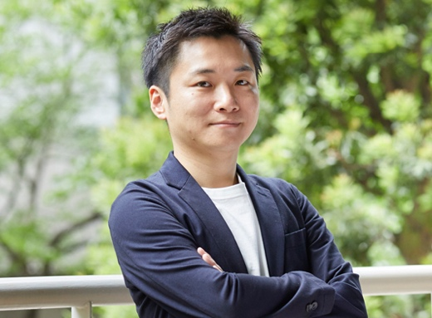

Masahito Hosokawa, Associate Prof, Waseda University

The 2nd seminar of the Waseda IARBD seminar series will be a lecture by Dr. Masahito Hosokawa, Associate Professor of Waseda University and CSO of bitBiome Inc., Japan. The lecture title is “Analyzing microbiome at the single-cell level”.
We look forward to your participation.

Date : | 25 February, 2022
Time : | 18:00-19:00 (Japan Standard Time)
Venue : | Webinar, Zoom (You will know the link after your registration.)
Lecturer : | Dr. Masahito Hosokawa  Associate Professor, Waseda University  Chief Scientific Officer, bitBiome, Inc.
Title : | “Analyzing microbiome at the single-cell level”
Registration Fee : | Free
Language : | English
Registration : | Please register in the following link:  https://forms.gle/x6RmercGUjnAPzne7
Deadline of Registration : | 23 February, 2022
Contact : | IARBD-office@list.waseda.jp（IARBD-Office）

Biography
Masahito Hosokawa obtained his Ph.D degree at Tokyo University of Agriculture and Technology in 2010. After a postdoctoral training at Shizuoka cancer center between 2011 and 2013, he joined Prof. Haruko Takeyama laboratory at Waseda University in 2013 (as Associate Professor from 2021) and started single-cell research as a JST-PRESTO researcher in 2015 to 2018. He found bitBiome, Inc. based on the developed single-cell technology in 2018. His research is interested in developing and applying novel microfluidic tools for single-cell genomics and transcriptomics. His awards include Bioindustry research award (2021), The Young Scientists’ Prize by the Minister of Education, Culture, Sports, Science and Technology (2019) and the JST PRESTO Innovation Award (2019).

Abstract
A wide variety of microbes exist in various natural environments, including the ocean, soil, and our bodies. However, most of them are uncultured microbes that have not been isolated and cultured, and there are many challenges to understanding their characteristics. We have developed a single-cell genome sequencing technology as a powerful tool to study these uncultured microorganisms. Single-cell genome analysis enables us to obtain genomic information from diverse microbial populations individually, which is difficult to conduct with conventional metagenome analysis. It can be used for various studies, such as metabolic analysis, screening for functional genes, and identification of useful chemical synthesis pathways. In addition, by comparing the acquired genomes within the same species, it is possible to perform a detailed comparative analysis at the strain level and even functional gene pathways. By taking advantage of these features, it is possible to describe the functions of microorganisms one by one. We are now attempting to create a genomic catalog of each microorganism using this technology in the study of the intestinal and environmental microbiome.

Organized by the Institute for Advanced Research of Bioscience Dynamics (IARBD)

